Contact: Carolina Milanesi
carolina.milanesi@kantarworldpanel.com
408 203 0137

US carrier loyalty to be threatened by first time smartphone buyers
Carrier loyalty among featurephone owners drops 16 percentage points compared to smartphone owners

New York City, May 7th – While current smartphone owners may not seem to pose a big threat to carriers in the next 12 months, featurephone owners do. Data released today by Kantar Worldpanel ComTech shows that of those featurephone owners looking to upgrade to a smartphone in the next 12 months an average of 26% are looking to change carrier in the process. Another 44% said they might change carrier in the next 12 months.

Figure 1: Intention to change carrier among featurephone owners looking to buy a smartphone in the next 12 months

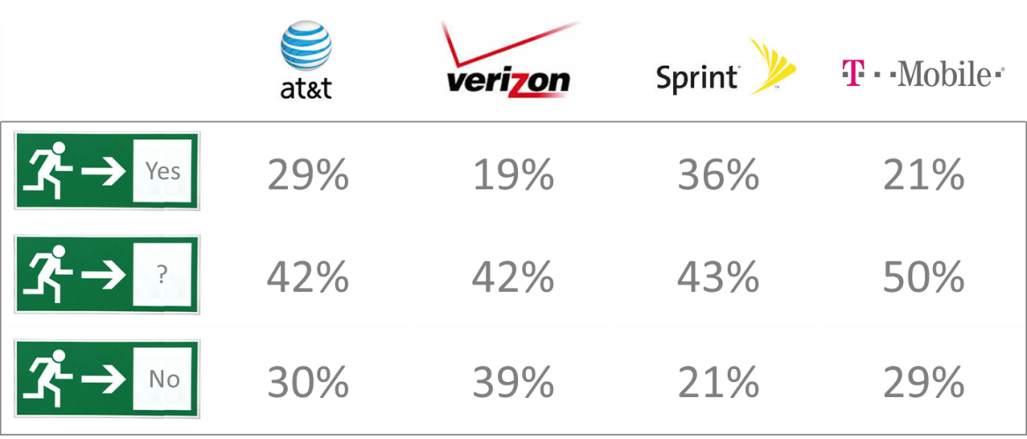

The quest for cheaper calls and lower data plans is driving the need for change. Handset availability is an issue only with featurephone owners at Sprint where 16% mentioned it. Customer service also does not seem to play a big role in carrier choice as an average of just 7% of featurephone owners intending to churn mentioned it.

As US carriers have raced to offer higher speed, better coverage and more payment options to smartphone users on contracts, users have grown more loyal to all carriers but Sprint. Among the smartphone owners interviewed, Verizon had the highest share of loyal subscribers in 1Q14 at 91%, followed closely by T-Mobile at 89% after the carrier saw a year-over-year increase of 18 percentage points (from 71% in 1Q13). AT&T ranked third in loyalty among its smartphone owners at 83%.

Keeping featurephone owners loyal seems to be much harder possibly due to the higher degree of flexibility that prepay offers to many of them. Among the top carriers, AT&T performs best with a 75% loyalty followed closely by Verizon at 72%.

Figure 2: Smartphone and featurephone loyalty by US carrier

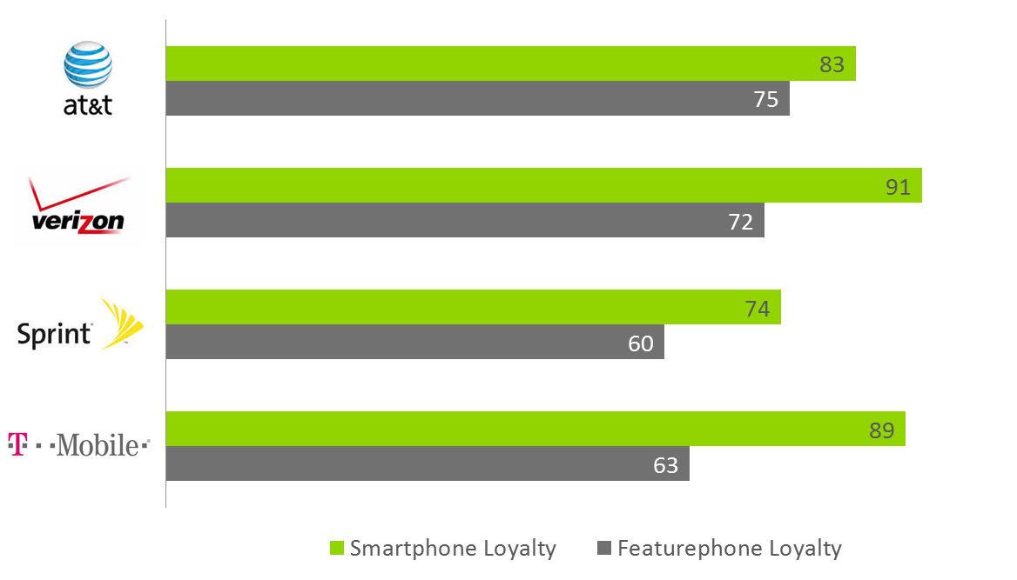

“Among those smartphone owners who changed carriers in 1Q14, two factors drove their decision-making,” said Carolina Milanesi, Chief of Research at Kantar Worldpanel Comtech. “For Sprint and T-Mobile, it was network coverage. For Verizon and AT&T, it was cost.”

Cheaper data plans and better network coverage were also named by the smartphone owners interviewed as reasons why they intend to change carriers over the next 12 months.

“Although the percentage of smartphone owners intending to change carrier is small enough not to affect carriers’ bottom line when it comes to subscribers, these users are a carrier’s most valuable customers,” Milanesi said. “Understanding why they intend to switch and where they will go is crucial.” Among the AT&T smartphone owners looking for change, 65% are looking at Verizon, while 56% of Verizon smartphone owners looking to change are considering T-Mobile. While device portfolio might not matter to most, it is interesting to note that the availability of one particular device has made a difference for T-Mobile. Of the 56% Verizon smartphones owners considering T-Mobile, 64% are considering buying an iPhone.

“The datapoints collected from smartphone owners and intenders indicate that while device portfolios and customer care are important, the real battleground in carriers’ acquisition and retention is quality of service and competitive pricing,” concluded Milanesi.

About Kantar Worldpanel ComTech’s Tablet Research
The information used in this release is based on the research extracted from the Kantar Worldpanel ComTech US consumer panel. Conducting over 240,000 interviews per year in the US alone, ComTech tracks ownership and purchasing of device, carrier connections, billing and usage in the mobile phone and tablet market. The data included in this release does not include enterprise sales.

About Kantar Worldpanel
Kantar Worldpanel is the world leader in consumer knowledge and insights based on continuous consumer panels. Its High Definition Inspiration™ approach combines market monitoring, advanced analytics and tailored market research solutions to deliver both the big picture and the fine detail that inspire successful actions by its clients. Kantar Worldpanel’s expertise about what people buy or use – and why – has become the market currency for brand owners, retailers, market analysts and government organisations globally.
With over 60 years’ experience, a team of 3,000, and services covering more than 50 countries directly or through partners, Kantar Worldpanel delivers High Definition Inspiration™ in fields as diverse as FMCG, impulse products, fashion, baby, telecommunications and entertainment, among many others.
For further information, please visit us at www.kantarworldpanel.com/comtech and follow us on Twitter https://twitter.com/kwp_comtech

About Kantar
Kantar is the data investment management division of WPP and one of the world's largest insight, information and consultancy groups. By connecting the diverse talents of its 13 specialist companies, the group aims to become the pre-eminent provider of compelling and inspirational insights for the global business community. Its 28,500 employees work across 100 countries and across the whole spectrum of research and consultancy disciplines, enabling the group to offer clients business insights at every point of the consumer cycle. The group’s services are employed by over half of the Fortune Top 500 companies.
For further information, please visit us at www.kantar.com
Twitter: Facebook: Google +: LinkedIn

