Press information

Alyona Levitin/Peter Rogers
Camargue
020 7636 7366
progers@camarguepr.com
alevitin@camarguepr.com

9 June 2014

Grocery market continues to grow
Dunnes top performer among the big supermarkets

The latest supermarket share figures from Kantar Worldpanel in Ireland, published today for the 12 weeks ending 25 May, show the Irish grocery market continuing its recent return to growth. Among the large retailers Dunnes has recorded the strongest sales performance, while Aldi and Lidl continue to grow market share.

David Berry, commercial director at Kantar Worldpanel, explains: “A gradual increase in the cost of food and drink has helped push price inflation to 2.6%, a record for 2014, which has increased the amount shoppers are spending at the tills and has kept the grocery market in growth.

“Dunnes is the only one of the big three retailers to grow its sales this period, albeit by a relatively modest 0.7%. Its clear strategy of offering ‘round euro’ promotional offers is appealing strongly to price-conscious consumers. Some 30% of Dunnes’ in-store sales are now sold on a round euro deal – up from just over 20% a year ago.”

Aldi and Lidl have both maintained their impressive double digit growth at 21.6% and 13.2% respectively. Aldi’s record share of 8.0% is held from last month while Lidl has reached a new record high of 7.9%.

David continues: “SuperValu’s sales remain in line with last year, with a slight dip in market share from 25.2% to 24.8%. Tesco continues to perform behind its main competitors, but the retailer’s sales have improved since the decline of almost 7% seen at the end of 2013. Interestingly, both retailers have succeeded in recruiting new shoppers this month. SuperValu has gained 32,000 additional shoppers and in so doing has recorded a seventh consecutive month of footfall growth. Tesco’s additional 12,000 customers is more modest, but the trend over the past year has been one of losing shoppers, so this is a welcome change for the retailer.”

- Ends -

An update on inflation
Grocery inflation stands at 2.6%* for the 12 week period ending 25 May 2014, up slightly from 2.5% last period.

*This figure is based on over 30,000 identical products compared year-on-year in the proportions purchased by Irish shoppers and therefore represents the most authoritative figure currently available. It is a ‘pure’ inflation measure in that shopping behaviour is held constant between the two comparison periods – shoppers are likely to achieve a lower personal inflation rate if they trade down or seek out more offers.

For further information, please visit us at www.kantarworldpanel.com and follow us on Twitter http://twitter.com/#!/KWP_EIRE

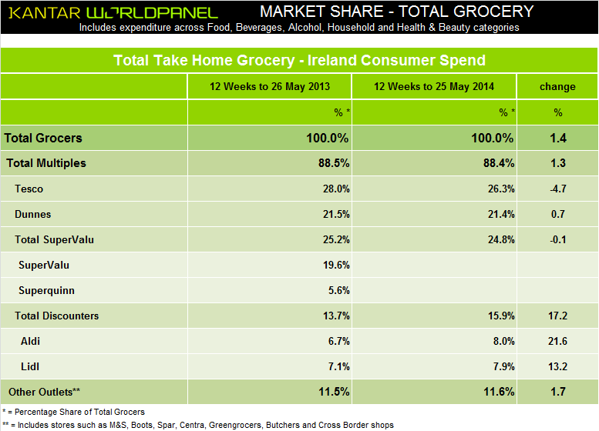

Notes to editors
For all publicly-quoted Worldpanel data, users of our research (including media) must ensure that data is sourced Kantar Worldpanel Ireland.
These findings are based on Kantar Worldpanel Ireland data for the 12 weeks to 25 May 2014. Kantar Worldpanel Ireland monitors the household grocery purchasing habits of 3,000 demographically representative households in the Republic of Ireland. All data discussed in the above announcement is based on the value of items being bought by these consumers, Kantar will only support data that is published in the context we have presented it and our own interpretation of these findings. We cannot be held responsible for any other interpretation of these findings.

For further information, please contact:

Peter Rogers
Camargue
+44 (0) 20 7636 7366
progers@kantarworldpanel.com

About Kantar Worldpanel

Kantar Worldpanel is the world leader in consumer knowledge and insights based on continuous consumer panels. Its High Definition Inspiration™ approach combines market monitoring, advanced analytics and tailored market research solutions to deliver both the big picture and the fine detail that inspire successful actions by its clients. Kantar Worldpanel’s expertise about what people buy or use – and why – has become the market currency for brand owners, retailers, market analysts and government organisations globally.

With over 60 years’ experience, a team of 3,500, and services covering 60 countries directly or through partners, Kantar Worldpanel delivers High Definition Inspiration™ in fields as diverse as FMCG, impulse products, fashion, baby, telecommunications and entertainment, among many others.

For further information, please visit us at www.kantarworldpanel.com.

About Kantar
Kantar is the data investment management division of WPP and one of the world's largest insight, information and consultancy groups. By connecting the diverse talents of its 12 specialist companies, the group aims to become the pre-eminent provider of compelling and inspirational insights for the global business community. Its 27,000 employees work across 100 countries and across the whole spectrum of research and consultancy disciplines, enabling the group to offer clients business insights at every point of the consumer cycle. The group’s services are employed by over half of the Fortune Top 500 companies.

For further information, please visit us at www.kantar.com
Twitter: Facebook: Google +: LinkedIn

