Contact:
Bill Daddi
Daddi Brand Communications
Bill@DaddiBrand.com
646-370-1341
917-620-3717

Carolina Milanesi
carolina.milanesi@kantarworldpanel.com
@caro_milanesi

Tablets’ Value Proposition Still Unclear to Mainstream Consumers
53% of US consumers interviewed in 4Q13 said they will not buy a tablet in the next 12 months.

New York, March 26 – In 4Q13, tablet penetration in the United States reached 37%, a growth of 54% compared to the same period in 2012, according to data released today by Kantar Worldpanel ComTech. Growth, however is slowing down year over year and the task of convincing consumers who have not yet invested in a tablet to take the plunge will become increasingly more difficult. Fifty-three percent of US consumers interviewed in 4Q13 said they will not buy a tablet in the next 12 months while 34% were unsure.
“As you would expect for a market that started in 2010 with the first generation iPad, tablet awareness among consumers is high with only 4% of non-owners saying they have never heard of such a device”, said Carolina Milanesi, Chief of Research at Kantar Worldpanel ComTech. “However, with 67% of people who were unsure if they will buy a tablet in the next 12 months saying that they know very little about them, there is no doubt that vendors need to improve their messaging around the value of owning and using a tablet.”
A weak value proposition is not only impacting the ability to convert tablet-rejecters but is also strictly linked to the fact that 47% of consumers who were unsure, and 25% of consumers who will definitely not buy a tablet in the next 12 months, find prices to still be too high. With cheaper models coming to market, the average spend on tablets in the US market has been decreasing from $326 in 4Q12 to $300 in 4Q13. “It is clear that wanting to know more about tablets, and finding them expensive, are two sides of the same coin. For mainstream consumers tablets are still a nice to have and not a must have,” continued Mrs. Milanesi.
Chart 1: Reasons for being unsure whether to buy a tablet or not
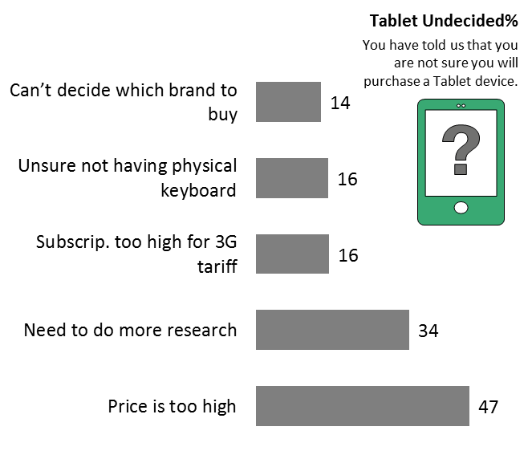
Chart 2: Reasons for not buying a tablet
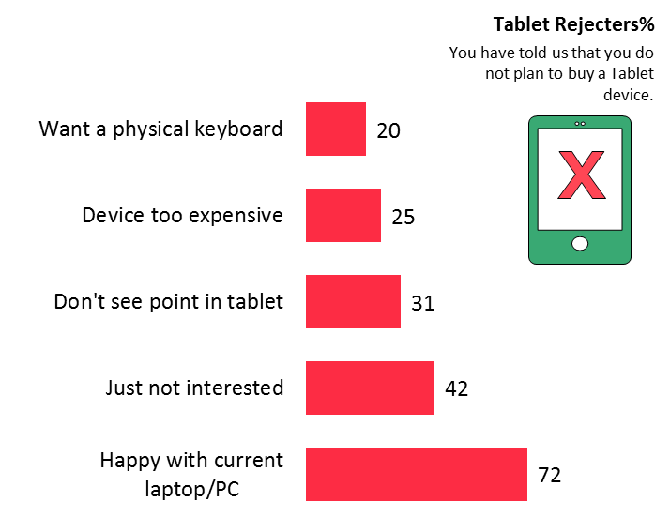
Among those who are not planning to buy a tablet 72% said that they are happy with their current laptop/PC and 42% said they are just not interested. Despite the common belief that the lack of the keyboard is a major factor for rejecting tablets, only 20% of our respondents said they are not planning to buy a tablet because of this.
“With more hybrid devices coming to market with larger screens, more powerful and power-efficient processors consumers’ consideration for tablets as an alternative to their current PCs will increase, if the price is right, of course” said Mrs. Milanesi.
Value proposition is determined in part by the level of engagement consumers can achieve with the device both in terms of frequency of use and the range of features and services they access. In essence, the higher the engagement, the higher the stickiness that the device, as well as the brand, can achieve.
Chart 3: Frequency of use of tablet areas by brand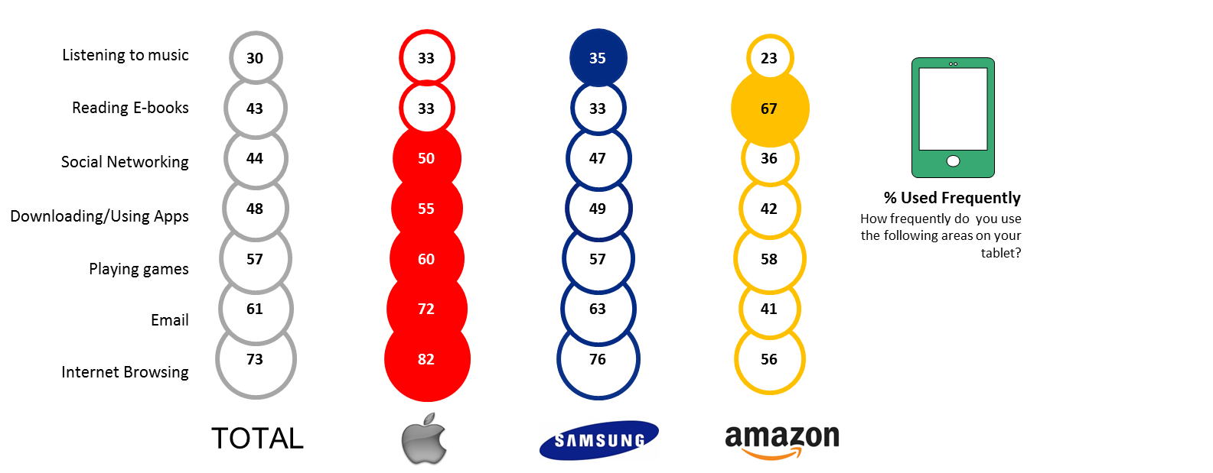
Apple, Amazon and Samsung are the top 3 brands in the US market, owning 43%, 24% and 11% of the installed base respectively. Looking at these brands, it is clear that iPad users are the most engaged with 32% of users saying they use their iPad constantly throughout the day and 42% saying they use it at least once a day. iPad users are also those that use the widest range of apps and services available on the device. Samsung tablets’ users come next with 24% using their devices constantly throughout the day and 41% using it at least once a day. Amazon comes last with only 18% of owners using their Kindle Fire constantly throughout the day and 40% using it at least once a day.
“As smartphone screen-sizes continue to creep up impacting tablets with smaller screens and hybrids continue to blur the line between tablets and PCs, vendors will have to increase their focus on clearly segmenting their offerings and sharpening their marketing message” concluded Mrs. Milanesi.
About Kantar Worldpanel ComTech’s Tablet Research
The information used in this release is based on the research extracted from the Kantar Worldpanel ComTech US consumer panel. Conducting over 240,000 interviews per year in the US alone, ComTech tracks ownership and purchasing of device, carrier connections, billing and usage in the mobile phone and tablet market. The data included in this release does not include enterprise sales.
About Kantar Worldpanel
Kantar Worldpanel is the world leader in consumer knowledge and insights based on continuous consumer panels. Its High Definition Inspiration™ approach combines market monitoring, advanced analytics and tailored market research solutions to deliver both the big picture and the fine detail that inspire successful actions by its clients. Kantar Worldpanel’s expertise about what people buy or use – and why – has become the market currency for brand owners, retailers, market analysts and government organizations globally.
With over 60 years’ experience, a team of 3,000, and services covering more than 50 countries directly or through partners, Kantar Worldpanel delivers High Definition Inspiration™ in fields as diverse as FMCG, impulse products, fashion, baby, telecommunications and entertainment, among many others.
For further information, please visit us at www.kantarworldpanel.com/comtech and follow us on Twitter https://twitter.com/kwp_comtech

About Kantar
Kantar is the data investment management division of WPP and one of the world's largest insight, information and consultancy groups. By connecting the diverse talents of its 13 specialist companies, the group aims to become the pre-eminent provider of compelling and inspirational insights for the global business community. Its 28,500 employees work across 100 countries and across the whole spectrum of research and consultancy disciplines, enabling the group to offer clients business insights at every point of the consumer cycle. The group’s services are employed by over half of the Fortune Top 500 companies.
For further information, please visit us at www.kantar.com
Twitter: Facebook: Google +: LinkedIn

